1.

Express 108 as a product of prime factors.
A.
2² x 3³
B.
2³ x 3²
C.
2 x 3⁴
D.
2³ x 3

2.

A football match starts at 2.20 p.m. and lasts for 1 hour 50 minutes. At what time will the game end?
A.
3.10 p.m.
B.
4.10 p.m.
C.
5.10 p.m.
D.
6.10 p.m.

3.

Which of the following is not a quadrilateral?
A.
Rhombus
B.
Parallelogram
C.
Rectangle
D.
Triangle

4.

Solve: 5x - (7x - 3) ≤ 9.
A.
x ≥ -3
B.
x ≤ -3
C.
x ≥ -6
D.
x ≤ 3

5.

Simplify

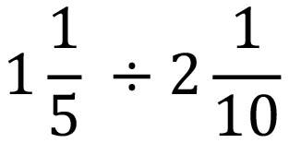
A.
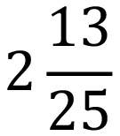
B.
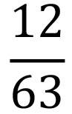
C.
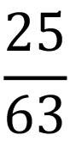
D.
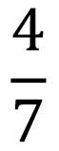

6.

Given that

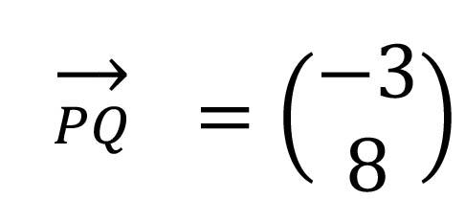

find,

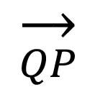

.
A.
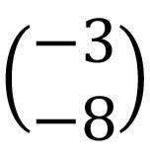
B.
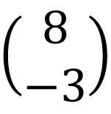
C.
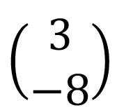
D.

7.

The point S(4, 3) is reflected in the y-axis, Find the coordinates of the image of S.
A.
(-3,4)
B.
(4,-3)
C.
(3,-4)
D.
(-4,3)

8.

Solve:

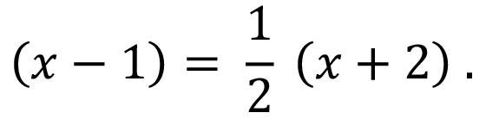
A.
4
B.
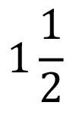
C.
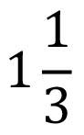
D.
0

9.

The longest chord of a circle is the
A.
segment.
B.
sector.
C.
circumference.
D.
diameter.

10.

Factorize completely xy - xm - my + m².
A.
(m-y)(x-m)
B.
(x-m)(y-m)
C.
(m-y)(m-x)
D.
(y-m)(m-x)

11.

Given that P(3,-2) and Q(-2,4) are points in a plane, find the gradient of the line joining P to Q.
A.
-⁶⁄₅
B.
⁶⁄₅
C.
⁵⁄₆
D.
-⁵⁄₆

12.

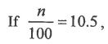

find the value of n.
A.
0.0105
B.
0.105
C.
105
D.
1050

13.

The rule of mapping is x → 2x² - 1. What number does x = 2 map to?
A.
9
B.
8
C.
7
D.
3

14.

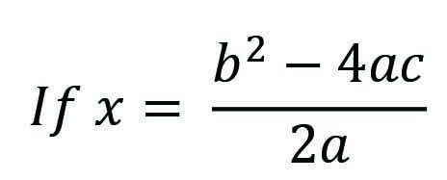

, find x when a = 2, b = -4 and c = -2.
A.
0
B.
8
C.
4
D.
16

15.

Arrange the following fractions from the lowest to the highest:

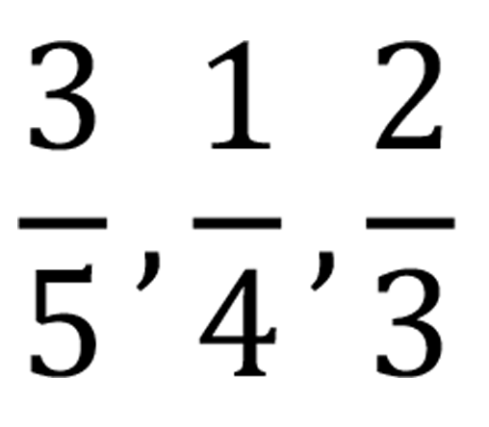
A.
¼ , ⅗ , ⅔
B.
⅔ , ¼ , ⅗
C.
⅔ , ⅗ , ¼
D.
⅗ , ¼ , ⅔

16.

A shop is rented at GH₵ 9.00 per month. How much money is paid in 1½ years?
A.
GH₵ 162.00
B.
GH₵ 135.00
C.
GH₵ 6.00
D.
GH₵ 13.00

17.

A certain number is subtracted from 12 and the result is multiplied by 3. If the answer is 21, find the number.
A.
6
B.
8
C.
5
D.
4

18.

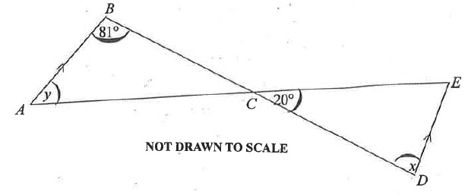
In the diagram, AB is parallel to DE, angle ABC = 81º and angle DCE = 20º.
Use the information to answer the equestion below:
What is the value of x?
A.
A. 20º
B.
61º
C.
81º
D.
101º

19.

In the diagram, AB is parallel to DE, angle ABC = 81º and angle DCE = 20º.
Use the information to answer the equestion below:
Find the value of y.
A.
20º
B.
81º
C.
79º
D.
101º

20.

Adjoa travelled 12km due north and 5km due east. How much far was she from her starting point?
A.
60km
B.
17km
C.
13km
D.
7km

21.

Which of the following is the largest set?
A.
{Whole numbers}
B.
{Composite}
C.
{Natural numbers}
D.
{Integers}

22.

Write 1930.54 in standard form.
A.
1.93054 X 10³
B.
1.93054 X 10⁻³
C.
1.93054 X 10⁻²
D.
1.93054 X 10²

23.

Expand: (2a - b)(a - b)
A.
2a² + 3ab - b
B.
2a² - 3ab - b²
C.
2a² + 3ab + b
D.
2a² - 3ab + b²

24.

The stem and leaf plot shows the weights (kg) of cocoa bags weighed in a week.
Use the information to answer the question below:
Stem | Leaf
4 | 0,5,7,9
5 | 1,3,4,5,7,8
6 | 0,2,3,4,4,4,4,5,6,8
7 | 1,2,3,4,5,8,8,9
8 | 2,3,5,6,9
9 | 4,5
How many bags of cocoa were weighed in the week?
A.
35
B.
29
C.
6
D.
41

25.

The stem and leaf plot shows the weights (kg) of cocoa bags weighed in a week.
Use the information to answer the question below:
Stem | Leaf
4 | 0,5,7,9
5 | 1,3,4,5,7,8
6 | 0,2,3,4,4,4,4,5,6,8
7 | 1,2,3,4,5,8,8,9
8 | 2,3,5,6,9
9 | 4,5
What is the median weight of the bags of cocoa?
A.
62 kg
B.
65 kg
C.
61 kg
D.
68 kg

26.

The stem and leaf plot shows the weights (kg) of cocoa bags weighed in a week.
Use the information to answer the question below:
Stem | Leaf
4 | 0,5,7,9
5 | 1,3,4,5,7,8
6 | 0,2,3,4,4,4,4,5,6,8
7 | 1,2,3,4,5,8,8,9
8 | 2,3,5,6,9
9 | 4,5
What is the modal weight of the bags of cocoa?
A.
68 kg
B.
60 kg
C.
64 kg
D.
65 kg

27.

If a =

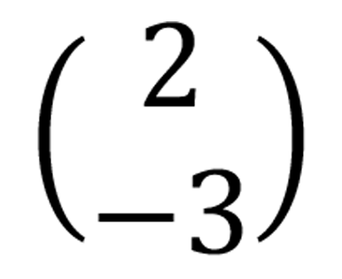

and b =

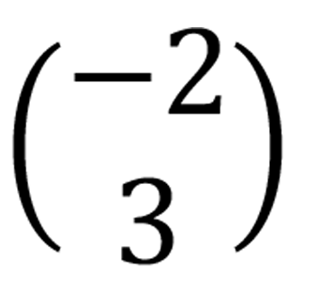

, find a + b
A.
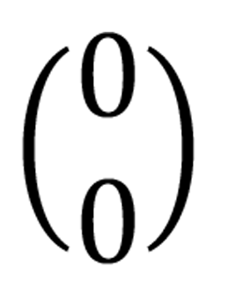
B.
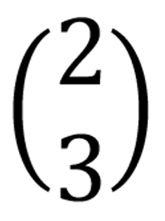
C.
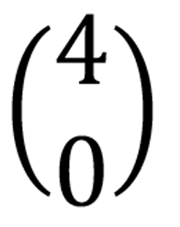
D.
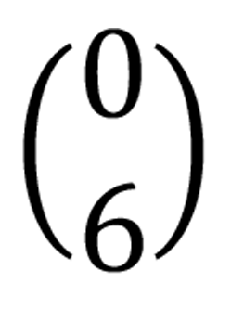

28.

For what value of x is 3^{x} = 81?
A.
2
B.
27
C.
4
D.
9

29.

Simplify: -15 - (-20) + (-10).
A.
-45
B.
-5
C.
-25
D.
5

30.

Express 3/8 as a decimal fraction.
A.
0.429
B.
0.375
C.
0.365
D.
0.625

31.

What is the length of the side of a square of area 225 cm²?
A.
15.00cm
B.
12.00cm
C.
112.50cm
D.
56.25cm

32.

What is the probability that a number greater than 5 shows up when a die is thrown?
A.
5/6
B.
1/6
C.
2/3
D.
1/3

33.

Given that 117(12+18) = 117(15+k), find the value of k
A.
15
B.
- 15
C.
-30
D.
30

34.

A mother has GH₵ 5.00 and gives each of her 3 children GH₵ 1.50 as pocket money. How much is left for her?
A.
GH₵ 3.50
B.
GH₵ 4.5
C.
GH₵ 0.15
D.
GH₵ 0.50

35.

A car travels 36 kilometres in an hour. Find its speed in metres per second.
A.
10 ms⁻¹
B.
100 ms⁻¹
C.
20 ms⁻¹
D.
200 ms⁻¹

36.

Peter had GH₵ 200.00 and spent GH₵ 83.00. What percentage of the money is left?
A.
29.06%
B.
70.94%
C.
58.50%
D.
41.50%

37.

If a trader made a profit of 10% in selling a shirt for GH₵ 44.00, find the cost price
A.
GH₵ 39.60
B.
GH₵ 38.50
C.
GH₵ 48.40
D.
GH₵ 40.00

38.

Express 15 : 12 in the form 1 : n.
A.
1 : 0.8
B.
1 : 12
C.
1 : 15
D.
1 : 1.2

39.

The ratio of farmers to children in a village is 13 : 11. If there were 312 farmers in the village, how many children were there?
A.
264
B.
143
C.
48
D.
169

40.

The volume of a cylinder is 40Π cm³. If the height of the cylinder is 10 cm, find the base radius
A.
1 cm
B.
4 cm
C.
2 cm
D.
3 cm

